**36**

**Wave Optics**

|  |
| --- |
| **CHAPTER OUTLINE** |

36.1 Young’s Double-Slit Experiment

36.2 Analysis Model: Waves in Interference

36.3 Intensity Distribution of the Double-Slit Interference Pattern

36.4 Change of Phase Due to Reflection

36.5 Interference in Thin Films

36.6 The Michelson Interferometer

* An asterisk indicates a question or problem new to this edition.

|  |
| --- |
| **ANSWERS TO THINK-PAIR-SHARE AND ACTIVITIES** |

**\*TP36.1 Conceptualize** Notice that the central maximum of the radio signal is right along the runway. Part (b) will explore what happens if the pilot is not headed along the central maximum.

**Categorize** We model the waves leaving the radio antennas as *waves in interference*.

**Analyze** (a) We use Equation 16.12:



(b) Let’s add some geometry to the figure:

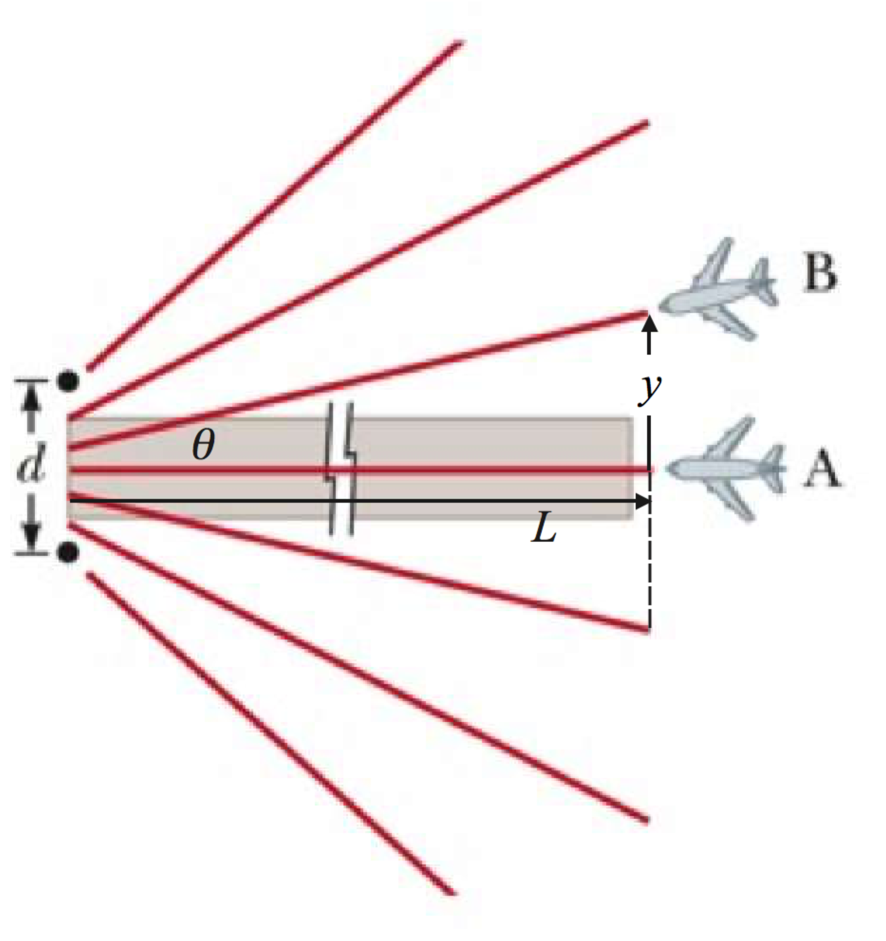

From the geometry, we see that

(1)



where *L* is the distance of the plane from the antennas and *y* is the distance of the plane from the centerline measured perpendicularly to the centerline.

We also have from Equation 36.2, for the interference pattern of the antennas,

(2)



Set the two expressions for the sine of the angle in Equations (1) and (2) equal and solve for *y*:

(3)



Substitute numerical values:



(c) Write Equation 36.2 two times, one for each of the frequencies:

(4)



(5)



Combine Equations (4) and (5):

(6)



In general, the only angle **1 = ** 2 that will satisfy this equation is **1 = ** 2 = 0. Therefore, the pilot locks onto a direction that gives strong interference maxima for both frequencies, telling her she is on the centerline. If she is on an angle that gives a strong maximum for one signal but not the other, she is not on a line corresponding to ** = 0.

Now consider, however, what happens if the frequency ratio is a ratio of small numbers, like in the problem statement. This corresponds to a wavelength ratio of . Substitute into Equation (6):



Now, suppose the pilot is of the centerline in such a way that she is flying along the *m*1 = 3 maximum and the *m*2 = 4 maximum. Then



Therefore, there could be an angle that gives a maximum for both signals, but is *not* on the centerline. Since the ratio of the two values of *m* *must* be a ratio of integers, we don’t make the frequencies have a ratio of integers, in order to avoid this possibility.

**Finalize** Real landing systems are more complicated than the simplified version presented here, but they operate on the same principles.]

*Answers:* (a) 10.0 m (b) 500 m (c) Answers will vary

**\*TP 36.2** **Conceptualize** Consider Figure 36.2a, which shows rays leaving the two slits and arriving at the screen in phase. Both the upper and lower rays of light have exactly the same number of wavelengths. Now imagine grabbing the first wavelength of the upper beam and squeezing it a little to compress it as if the wave were a spring. Now the same number of wavelengths of the upper ray doesn’t quite reach the screen. It would reach the screen if the ray were tilted upward a bit so that it strikes the screen above point *O*. Then tilt the lower ray up a bit so it arrives at the same point. This gives us the shifted central fringe as in Figure TP36.2. The squeezing of the first wavelength is an analog to the shortening of the wavelengths of light as they travel through the plastic material. (This analog would actually involve lengthening of the wavelengths of the lower ray to stretch it out to   
reach the new central maximum. However, we will be taking the limit that the distance to the screen is much larger than the slit separation. In this case, the outgoing rays from the slit are parallel, and the required lengthening of the wavelength on the lower ray becomes negligible.)

**Categorize** We model the rays leaving the slits as *waves in interference.*

**Analyze** Let us set up the physical situation at the slit in a way similar to that shown in Figure 36.4b:

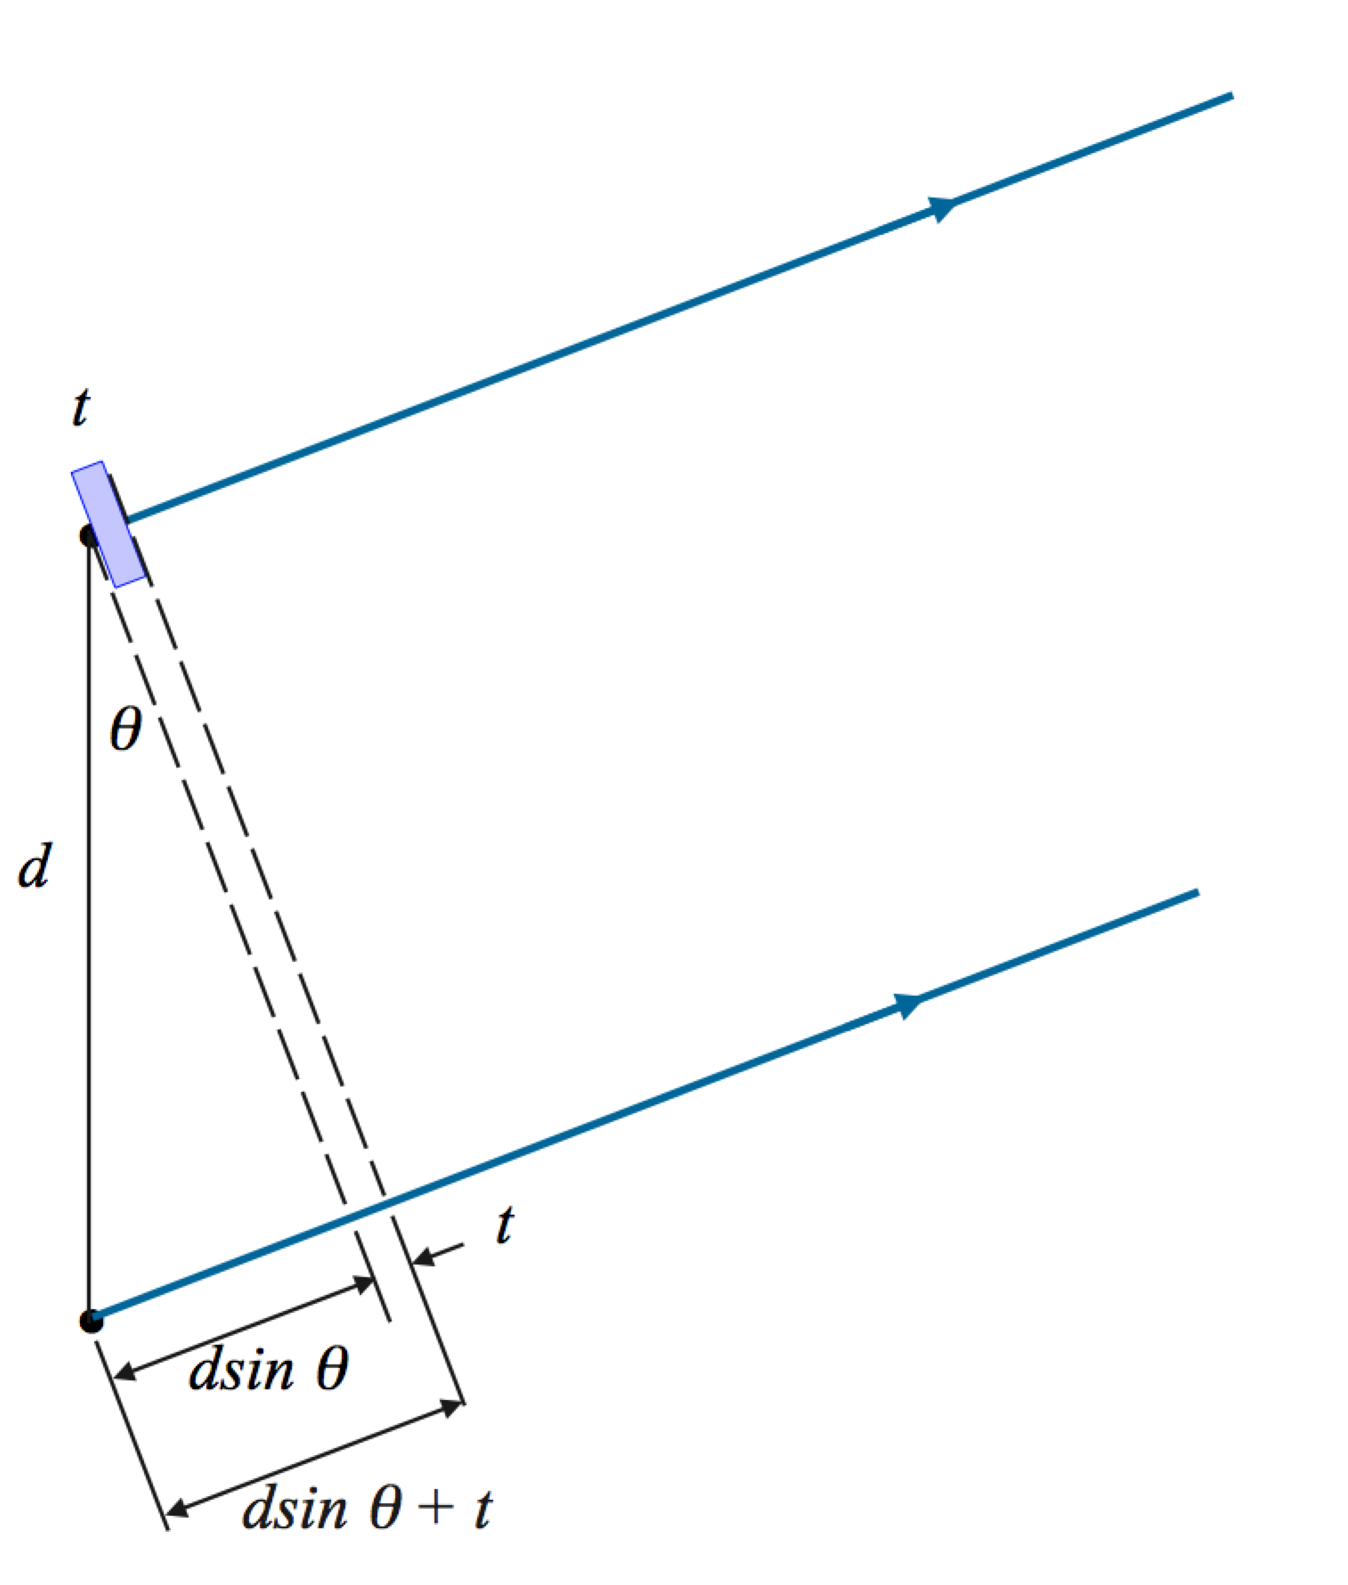

In the diagram, everything to the left of the left-hand dashed line is the same as in Figure 36.4b. Now we add the piece of plastic of thickness *t* right at the upper slit as shown. We draw a second dashed line grazing its surface and extending parallel to the first dashed line down to the lower ray. To the right of this dashed line, both rays have the same number of wavelengths all the way to the screen, since they travel the same distance in air. Because the central maximum corresponds to an equal *total* number of wavelengths in both rays, the number of wavelengths of the upper ray in the plastic material must equal the number of wavelengths in the lower ray between the source and the *second* dashed line. Therefore, we must have

(1)



where *n* is the wavelength of the light in the plastic. From Equation 34.6, we can replace *n*:

(2)



Now, looking at the geometry in Figure TP36.2, we see that

(3)



Substitute Equation (3) into Equation (2) and solve for *y*’:



**Finalize** We can test this expression with a couple of limits. For example, if *n*→ 1, *y’*→ 0. This makes sense, since if *n* = 1, the material of thickness *t* is air. Notice also, if *t*→ 0, *y’*→ 0. If the thickness of the material goes to zero, it has no effect on the interference pattern. What if *L* increases? Then *y’* increases by the same factor. Moving the screen does not affect the angle ** to the central maximum, so the ratio of *y’* to *L* remains fixed. If we decrease *d*, that will cause *y’* to increase. Does that make sense?]

*Answer:*



**\*TP 36.3 Conceptualize** The thickness of the film of ethanol varies in time due to evaporation, so the reflected light will cycle between maxima and minima due to interference. The graph does not show the intensity going to zero because the amount of reflection from the ethanol surface is not necessarily the same as the amount of reflection from the glass bottom of the dish, so there is not likely to be complete cancellation.

**Categorize** This is clearly a problem involving interference in thin films.

**Analyze** Table 34.1 shows that the index of refraction of glass is larger than that of the ethanol. Therefore, the ethanol is between two substances, one with a smaller index of refraction (air) and the other with a larger index (glass). The condition for constructive interference is Equation 36.13:

(1)



where *h* is the thickness of the layer of ethanol. (We will use *h* rather than *t* because we will also have time *t* as a variable.) Solve Equation (1) for this thickness:

(2)



The rate of evaporation is expressed as the time rate of change of the volume of the ethanol. Express this in terms of the dimensions of the layer of ethanol:

(3)



Substitute Equation (2) into Equation (3):

(4)



where we have recognized that the only quantity that varies with time is *m*, the order number for the interference. Of course, *m* can only have integer values, so it does not vary continuously. Let’s look at the graph of intensity and find the time at which the fourth and last maximum in the graph occurs:

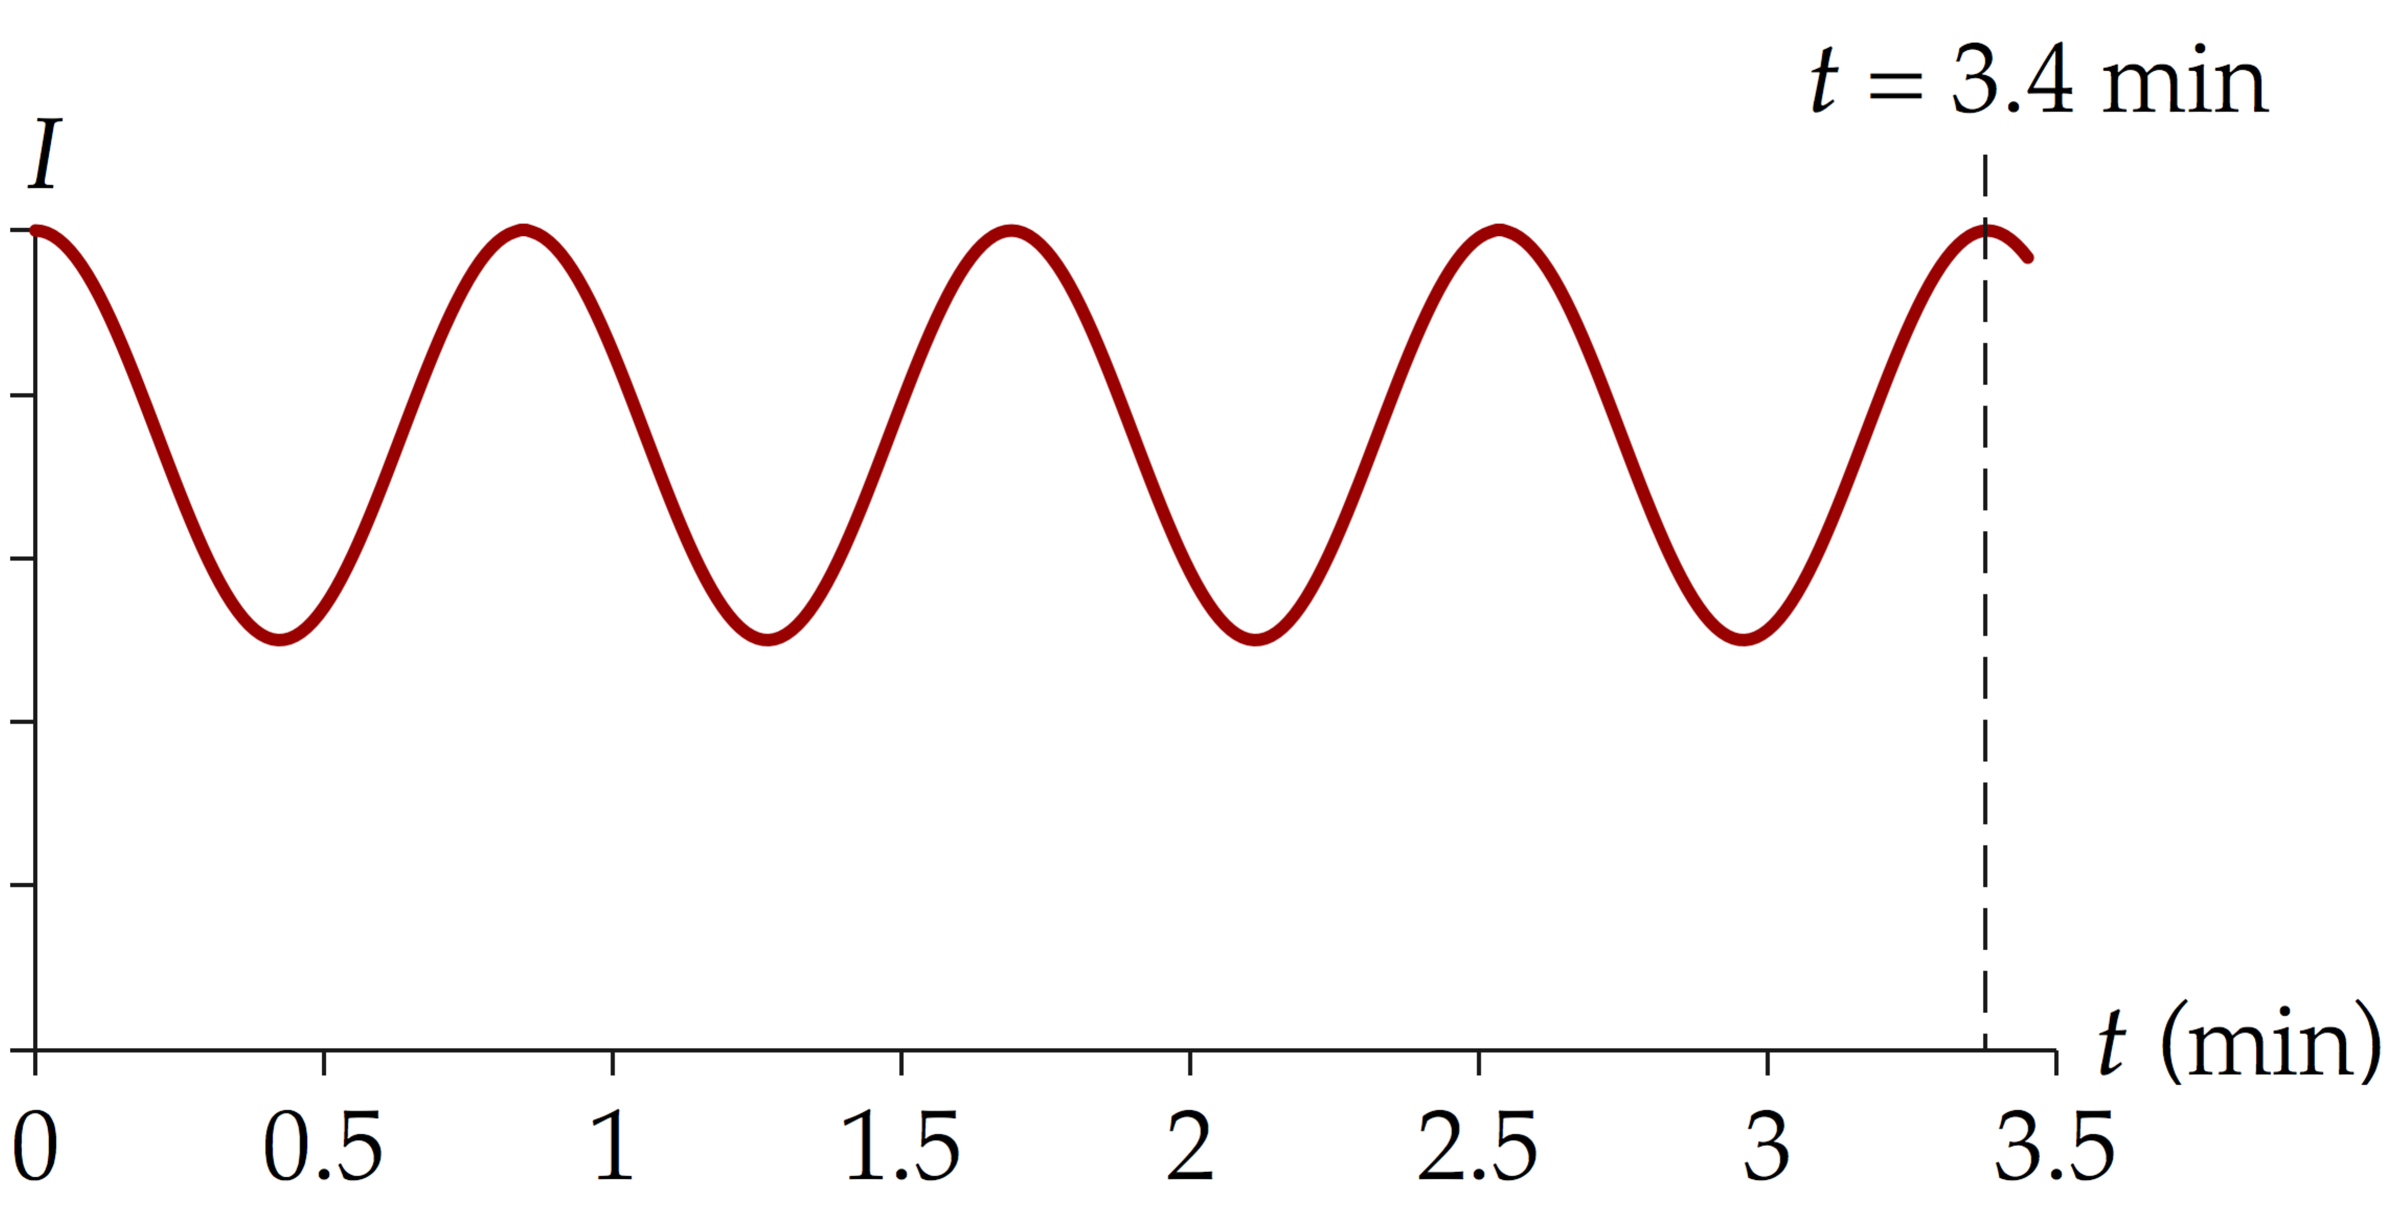

Therefore, it requires 3.4 min for *m* to change by 4, so,



Substitute numerical values into Equation (4):



**Finalize** Notice that we kept only two significant figures in the final result due to the uncertainty in measuring the time in the graph.]

*Answer:* 3.6 × 10–5 mL/s

|  |
| --- |
| **SOLUTIONS TO END-OF-CHAPTER PROBLEMS** |

**Section 36.2 Analysis Model: Waves in Interference**

**P36.1** The angular locations of the bright fringes (or maxima) is given by Equation 36.2:



Solving for m and substituting 30.0° gives



There are 320 maxima to the right, 320 to the left, and one for *m* = 0 straight ahead at There are therefore



**P36.2** We use Equation 36.2, to find the angle for the *m* = 1 fringe:



The sine of the angle is greater than 1, which is impossible. Therefore, there is no *m* = 1 fringe on the screen whose position can be measured. In fact, there is no interference pattern at all, just a bright area of microwaves directly behind the double slit.

**P36.3** The location of the bright fringe of order *m* (measured from the position of the central maximum) is

.



For first bright fringe to the side, *m* = 1. Thus, the wavelength of the laser light must be



**P36.4** (a) For a bright fringe of order *m*, the path difference is , where *m* = 0, 1, 2,… At the location of the third order bright fringe,



(b) For a dark fringe, the path difference is , where   
*m* = 0, 1, 2,… At the third dark fringe, *m* = 2 and



**P36.5** We do not use the small-angle approximation here because the angle is greater than 10°. For the first bright fringe, *m* = 1, and we have



and



**P36.6** Taking *m* = 0 and *y* = 0.200 mm in Equations 36.3 and 36.4 gives



Geometric optics or a particle theory of light would incorrectly predict bright regions opposite the slits and darkness in between. But, as this example shows, interference can produce just the opposite.

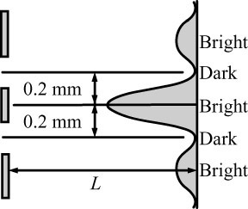

**ANS. FIG. P36.6**

**P36.7** The angle *θ* of the 50th-order fringe is given by



The distance *x* from the slit to the screen and the distance *y* of the *m*th-order fringe from the center of the central maximum are related by As the student approaches the screen at speed *v*, the distances *x* and *y* decrease but their ratio stays the same. Therefore,



where *dy*/*dt* is negative because the distance *y* shrinks. The *speed* of the fringe is



Thus, the speed of the 50th-order fringe is



**P36.8** The angle *θ* of the *m*th-order fringe is given by



The distance *x* from the slit to the screen and the distance *y* of the *m*th-order fringe from the center of the central maximum are related by As the student approaches the screen at speed *v*, the distances *x* and *y* decrease but their ratio stays the same. Therefore,



where *dy*/*dt* is negative because the distance *y* shrinks. Thus, the speed of the *m*th-order fringe is



**P36.9** From the diagram, the path difference between rays 1 and 2 is



For constructive interference, this path difference must be equal to an integral number of wavelengths:



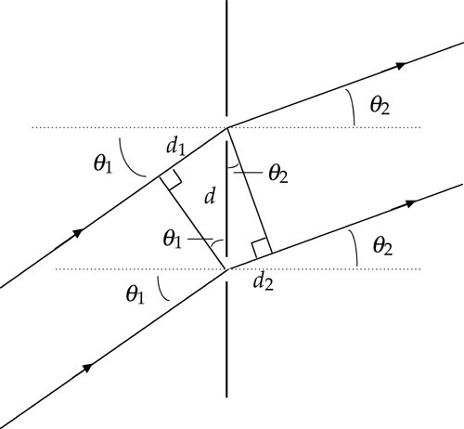

**ANS. FIG. P36.9**

**P36.10** For a double-slit system, the path difference of the two wave fronts arriving at a screen is and the phase difference is



(a) For *θ* = 0.500°,



(b)



(c) If then



(d) If then



**\*P36.11 Conceptualize** If the orange color is pure at the *m* = 3 *maximum* for the orange light, that means that that same point must be a *minimum* for the offending wavelength.

**Categorize**We model the laser beams as *waves in interference.*

**Analyze** Based on our understanding in the Conceptualize step, Equation 36.2 represents the situation for the orange light, with *m* = 3, and Equation 36.3 represents the situation for the offending light with *m* unknown. Since the same point on the screen is involved for both wavelengths, *d*sin** in both equations has the same value. So set the right-hand sides of the equations equal:

(1)



Solve for the wavelength of the offending light:

(2)



We don't know the value of *m* for the offending light, but we know that it is an integer. Let’s evaluate the offending wavelength for possible values of *m*:

|  |  |
| --- | --- |
| ***m*** | ****offending (nm)** |
| 0 | 3 540 |
| 1 | 1 180 |
| 2 | 708 |
| 3 | 506 |
| 4 | 393 |

The problem statement implies that you can *see* the offending light. The first two values, for *m* = 0 and *m* = 1, give wavelengths that are outside the range of visible light shown in Table 33.1. The value *m* = 2 gives a wavelength just outside the visible range, in the infrared. The possibility *m* = 4 results in a wavelength of 393 nm, which is just outside the visible range, in the ultraviolet. The only possibility is *m* = 3 for the offending light, giving a wavelength of 506 nm.

**Finalize** The wavelength we found is in the green portion of the visible spectrum. Notice that we had no information about the slit width or any distances, such as the distance from the slit to the screen. Yet we could still solve the problem! Are there other orange fringes that will be pure beyond *m* = 3? Will any of the offending green fringes be pure?]

*Answer:* 506 nm

**\*P36.12 Conceptualize** The diagram below shows the physical setup of the radio telescope, some geometry, and the reason why the telescope receives no signals at a certain angle:

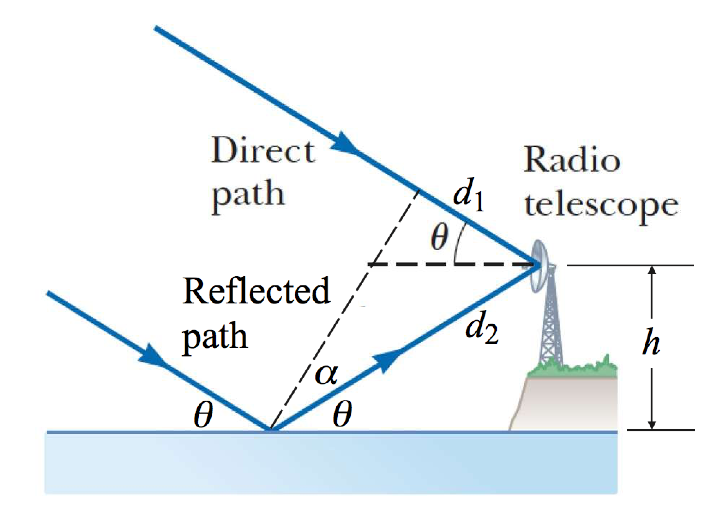

At a particular angle **, the radio signal reflected from the water surface is interfering destructively with the direct signal from the radio source, causing cancellation of the waves. Keep in mind that the radio wave reflecting off the water undergoes a 180° phase shift.

**Categorize** We model the two radio signals as *waves in interference.*

**Analyze** By drawing the dashed line perpendicular to the radio waves, we see that the path difference between the two waves arriving at the antenna is

(1)



From the right triangle with hypotenuse *d*2 and *d*1 as one leg, we see that

(2)



By extending the incoming ray that is reflected from the water in its original direction, we see that

(3)



Combining Equations (1), (2), and (3), we find the physical path difference:

(4)



From the right triangle with hypotenuse *d*2 and *h* as one leg, we see that

(5)



Substitute Equation (5) into Equation (4):

(6)



Now, incorporate the fact that the reflection from the water causes a half-wavelength phase shift to find the *optical* path difference:

(7)



To have destructive interference between the direct and reflected waves, we must have

(8)



Combine Equations (7) and (8) to find the physical path difference:

(9)



Substitute Equation (9) into Equation (6):

(10)



Because there is only *one* angle on a given night at which the signals cancel, this must be a first-order cancellation, so that *m* = 1.

Finally, the angles will vary from night to night because of the variation in vertical position of the water surface due to the tides. This results in a variation of the height *h* of the antenna above the water surface. Therefore, the variation in the heights of the tides for your location for the month is

(9)



Substitute numerical values:



**Finalize** This is a large tidal range, but not the world’s largest. The Bay of Fundy in Canada has exhibited tidal ranges of up to 16.3 m.]

*Answer:* 6.59 m

**P36.13** (a) The path difference and when *L* >> *y*:



(b) , or



(c) Point *P* will be a because the path difference is an integer multiple of the wavelength.



**P36.14** (a)



(b)



(c) From (b),



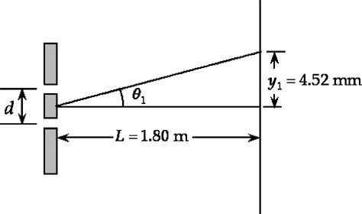

**ANS. FIG. P36.14**

The sine and the tangent are very nearly the same, but only because the angle is small. From for *m* = 1:



(d) From for the order *m* bright fringe,



(e)



(f)



**Section 36.3 Intensity Distribution of the   
Double-Slit Interference Pattern**

**P36.15** We use trigonometric identities to write



and



The equation is satisfied if we require



or



and



**\*P36.16 Conceptualize** Study Figure 36.4 carefully, so that you understand the origin of the intensity difference on the screen.

**Categorize** The problem involves the *waves in interference* model in the special case of two-slit interference.

**Analyze** Although the light waves are in phase as they leave the slits, their phase difference ** at *P* dependson the path difference according to Equation 36.1: ** = *r*2 – *r*1 = *d*sin**. A *path* difference of ** (for constructiveinterference) corresponds to a *phase* difference of 2** rad. Therefore, a path difference of ** isthe same fraction of ** as the phase difference ** is of 2**:

(1)



Solve Equation (1) for ** and substitute from Equation 36.1:

(2)



Use the superposition principle to combine the electric field magnitudes given in the problem statement to find an expression for the magnitude of the resultant electric field at point *P*:

(3)



We can simplify this expression by using the trigonometric identity

(4)



Identifying *A* as (*t* + **) and *B* as *t*, use Equation (4) to rewrite Equation (3):



The intensity of the light is proportional to the square of the electric field magnitude, so

(6)



where *a*2 is a constant of proportionality. The intensity seen or measured on a screen will be the time-averaged intensity, so integrate the time-dependent intensity in Equation (6) over one cycle:



where we have gathered all of the constants together and identified the combination of constants as *I*max. The evaluation of the integral as uses the same argument as that associated with Figure 32.5.



Finally, substitute Equation (2) into Equation (7):

(8)



**Finalize** Equation (8) is identical to Equation 36.9 in the text.]

**P36.17** In for angles between −0.3° and +0.3° we may take sin *θ* = *θ* (in radians) to find



This equation is correct assuming *θ* is in radians; but we can then equally well substitute in values for *θ* in degrees and interpret the argument of the cosine function as a number of degrees. We get the same answers for *θ* negative and for *θ* positive. We evaluate

|  |  |  |  |  |  |  |  |
| --- | --- | --- | --- | --- | --- | --- | --- |
| *θ* degrees | −0.30 | −0.25 | −0.20 | −0.15 | −0.10 | −0.05 | 0.0 |
| *I/I*max | 0.101 | 1.00 | 0.092 | 0.659 | 0.652 | 0.096 | 1.00 |
| *θ* degrees | 0.05 | 0.10 | 0.15 | 0.20 | 0.25 | 0.30 |  |
| *I/I*max | 0.096 | 0.652 | 0.659 | 0.092 | 1.00 | 0.101 |  |

**TABLE P36.17**

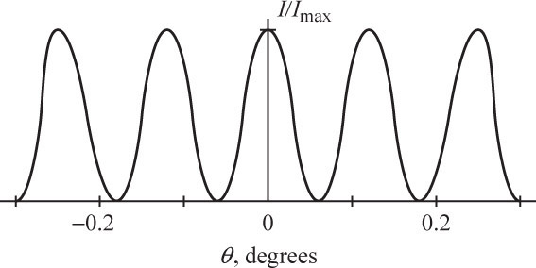

**ANS. FIG. P36.17**

The cosine-squared function has maximum values of 1 at *θ* = 0, at   
*θ* = 0.125°, and at *θ* = 0.250°. It has minimum values of zero halfway between the maximum values. The graph then has the appearance shown.

**P36.18** (a) The resultant amplitude is



where .



Expanding,



Then the intensity is



where we have substituted the time average of , which is . The maximum intensity occurs at :



Therefore, the ratio of intensity to maximum intensity is



(b) Look at the *N* = 3 graph in the textbook Figure 36.6. The intensity is zero at two places between the relative maxima, attained where . The relative secondary maximum in the middle occurs at , where .



(c) The larger local maximum happens where , giving . The ratio of intensities at primary versus secondary maxima is .



**Section 36.5 Interference in Thin Films**

**P36.19** There are a total of two phase reversals caused by reflection, one at the top and one at the bottom surface of the coating.

so



The minimum thickness of the film is therefore



**P36.20 (**a) With phase reversal in the reflection at the outer surface of the soap film and no reversal on reflection from the inner surface, the condition for constructive interference in the light reflected from the soap bubble is



where *m* = 0, 1, 2,…. For the lowest order reflection (*m* = 0), and the wavelength is



(b) A thicker film would require a higher order of reflection, so use a larger value of *m*.

(c) From (a) above, for a given wavelength, the thickness would be



The next greater thickness of soap film that can strongly reflect 638 nm light corresponds to *m* = 1, giving



and the third such thickness (corresponding to *m* = 2) is



**P36.21** (a) The film thickness is *t* = 1.00 × 10–5 cm = 1.00 × 10–7 m = 100 nm. Since the light undergoes a 180° phase change at each surface of the film, the condition for *constructive* interference is

, or



Therefore, the wavelengths intensified in the reflected light are, for *m* = 1, 2, and 3:



(b) Because , all reflection maxima are in the ultraviolet and beyond.



**P36.22** (a) The light reflected from the top of the oil film undergoes phase reversal. Since 1.45 > 1.33, the light reflected from the bottom undergoes no reversal. For constructive interference of reflected light, we then have



or



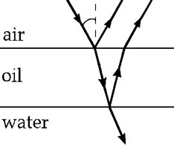

**ANS. FIG. P36.22**

Substituting for *m* gives:

*m* = 0, (infrared)



*m* = 1, (green)



*m* = 2, (ultraviolet)



Both infrared and ultraviolet light are invisible to the human eye, so the dominant color in reflected light is



(b) The dominant wavelengths in the transmitted light are those that produce destructive interference in the reflected light. The condition for destructive interference upon reflection is



or



Substituting for *m* gives:

*m* = 1, (near infrared)



*m* = 2, (violet)



*m* = 3, (ultraviolet)



Of these, the only wavelength visible to the human eye (and hence the dominant wavelength observed in the transmitted light) is 406 nm. Thus, the dominant color in the transmitted light is .



**P36.23** Reflection off the lower glass plate causes a phase reversal. The condition for bright fringes is

*m* = 0, 1, 2, 3, ….



From ANS. FIG. P36.23, observe that



The condition for a bright fringe becomes



Thus, for fixed *m* and *λ*, *nr*2 = constant.

Therefore,

and



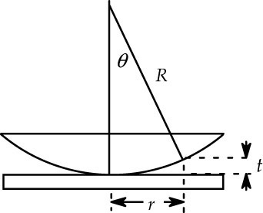

**ANS. FIG. P36.23**

**\*P36.24 Conceptualize** The radius of the circular oil slick will allow us to find its area. The oil acts as a thin film floating on the water surface. The optical information will allow us to find its thickness. From these measurements, we can find the volume of the oil that was spilled.

**Categorize** The light waves will be modeled as *waves in interference* in the special case of interference on thin films.

**Analyze** Because the index of refraction of the oil is between that of air and water, there will be a 180° phase shift both at the reflection of light from the oil surface and at the water surface beneath the oil. Therefore, the condition for constructive interference for light reflected from the oil is given by Equation 36.13:

(1)



The oil forms a very thin disk around the location at which the oil spilled, so the volume of the oil is

(2)



Substitute numerical values, assuming the minimum order number of *m* = 1:



**Finalize** This result is larger than the limit of 10.0 m3 indicated in the problem statement. We assumed the interference observed was represented by *m* = 1. Because the volume is proportional to *m*, if the interference represents a higher value of *m*, the volume of oil spilled is even larger. In reality, the measurement would be complicated by variations of thickness in the oil and the effects of wave motion on the slick.

Answer: 11.3 m3

**P36.25** Light waves are partially reflected and transmitted by the partially aluminized glass surfaces on the front and back surfaces of the filter. For maximum transmission, we want destructive interference between the waves reflected from the front and back surfaces of the film: the result of this interference is that most light of the line is transmitted through the filter.



(a) If the surrounding glass has refractive index greater than 1.368, light reflected from the front surface of the filter (glass-filter interface) suffers no phase reversal and light reflected from the back surface of the filter (filter-glass interface) does undergo phase reversal. This effect by itself would produce destructive interference, so we want the distance down and back to be one whole wavelength in the film: .



(b) The filter will undergo thermal expansion. As *t* increases in   
2*nt* = *λ*, so does



(c) Destructive interference for reflected light happens when :



**P36.26** (a) The missing wavelength in reflected light is caused by destructive interference. The index of the coating (1.38) is greater than that of air (1.00), and the index of the glass (1.52) is greater than that of the coating; therefore, light waves reflected off the front and back surfaces of the coating undergo phase reversals. For destructive interference,

*m* = 0, 1, 2, 3, … and *n* = 1.38



For the minimum thickness, *m* = 0:



(b)



**Section 36.6 The Michelson Interferometer**

**P36.27** When the mirror on one arm is displaced by the path difference changes by A shift resulting in the reversal between dark and bright fringes requires a path length change of one-half wavelength. Therefore, where in this case, *m* = 250.



**Additional Problems**

**P36.28** The wavelength is



Along the line *AB* the two traveling waves going in opposite directions add to give a standing wave. The two transmitters are exactly 2.00 wavelengths apart and the signal from *B*, when it arrives at *A*, will always be in phase with transmitter *B.* Since *B* is 180° out of phase with *A*, the two signals always interfere destructively at the position of *A* to form a node.

The first antinode (point of constructive interference) is located at distance

from the node at *A*



**P36.29** The same source will radiate light into the sugar solution with wavelength . In other words, the condition for bright fringes becomes



Also, for small angles, as is the case here



The first side bright fringe (*m* = 1) is separated from the central bright fringe by distance *y* described by



solving for *y* gives



**P36.30** (a) Where fringes of the two colors coincide we have

, requiring



(b) *λ* = 430 nm,



which cannot be reduced any further. Then *m* = 51, *m*′ = 43. Then,



and



**P36.31** Constructive interference occurs where the phases of the waves differ by integral multiples *m* of 2*π* :



which becomes



**P36.32** Assume the distance between gaps is 2 cm.

(a) Two adjacent directions of constructive interference for 600-nm light are described by with Then,



Thus,



and



(b) We choose Then,



Which gives The frequency is then



(c) Millimeter waves are .



**P36.33** If the center point on the screen is to be a dark spot rather than bright, passage through the plastic must delay the light by one-half wavelength. Calling the thickness of the plastic *t*, or where *n* is the index of refraction for the plastic.



**P36.34** There is no phase shift upon reflection from the upper surface (glass to air) of the film, but there will be a shift of due to the reflection at the lower surface of the film (air to metal).



The total phase difference in the two reflected beams is then



For constructive interference, or



Thus, the film thickness for the *m*th order bright fringe is



and the thickness for the *m* – 1 bright fringe is:



Therefore, the change in thickness required to go from one bright fringe to the next is



To go through 200 bright fringes, the change in thickness of the air film must be



Thus, the increase in the length of the rod is



From



we have:



**P36.35** From Figure P36.35, observe that the distance that the ray travels from the top of the transmitter to the ground is



Including the phase reversal due to reflection from the ground, the total shift between the two waves (transmitter-to-ground-to-receiver and transmitter-to-receiver) is



For constructive interference,



and for destructive interference



(a) The longest wavelength that interferes constructively is, for *m* = 1,



(b) The longest wavelength that interferes destructively is, for *m* = 1,



**P36.36** From Figure P36.35, observe that the distance that the ray travels from the top of the transmitter to the ground is



Including the phase reversal due to reflection from the ground, the total shift between the two waves (transmitter-to-ground-to-receiver and transmitter-to-receiver) is



For constructive interference,



and for destructive interference



(a) The longest wavelength that interferes constructively is, for *m* = 1,



(b) The longest wavelength that interferes destructively is, for *m* = 1,



**P36.37** (a) There is a phase reversal by reflection at the flat plate. Constructive interference in the reflected light requires .



The first bright ring has *m* = 0 and the 55th has *m* = 54, so at the edge of the lens



We can find the distance *t* from the curved surface down to the flat plate by considering distances measured from the center of curvature:



Solving for *R* gives



(b) so



**P36.38** From Equation 36.9, for wavelength ,



For the same *y*, *d*, and *L,* let be the wavelength for which



Then,



Note that in this problem, must be expressed in radians.



**P36.39** Light reflecting from the upper interface of the air layer suffers no phase change, while light reflecting from the lower interface is reversed 180°. Then there is indeed a dark fringe at the outer circumference of the lens, and a dark fringe wherever the air thickness *t* satisfies

2*t* = *mλ*, *m* = 0, 1, 2, ….

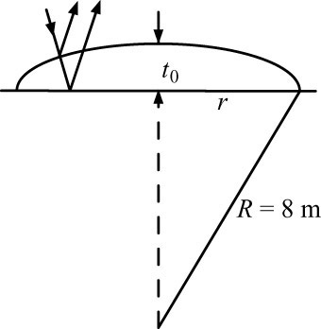

**ANS. FIG. P36.39**

(a) At the central dark spot, *m* = 50 and



(b) In the right triangle,



The last term is negligible. Then,



(c)



**P36.40** Reflection off the top surface of the wedge produced a phase reversal, but light reflecting off the bottom surface produces no phase change. Thus, a first *dark* fringe occurs at the thin end of the wedge. For bright fringes in the thin film, the thickness is given by Equation 36.12:



The first fringe corresponds to *m* = 0, the second to *m* = 1, etc.; so the *N*th fringe corresponds to *N* = *m* + 1.

To find how many fringes are present, we solve for *m* by setting *t = h*:



So, the number of fringes is *N* = *m* + 1 = 4 741. This number is less than 5000.

**P36.41** We may treat this as a double-slit interference problem, where *d* = 2*h*, but with maxima and minima interchanged because of phase reversal caused by the reflection off the mirror:

bright fringe



and for small angles; hence,



The spacing between consecutive fringes corresponding to *m* and *m* + 1 is



so



**P36.42** The shift between the waves reflecting from the top and bottom surfaces of the film at the point where the film has thickness *t* is , with the factor of being due to a phase reversal at *one* of the surfaces.



For the dark rings (destructive interference), the total shift should be with   
*m* = 0, 1, 2, 3, … . This requires that . To find *t* in terms of *r* and *R*,

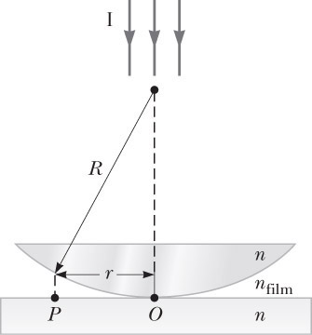

**ANS. FIG. P36.42**



Since *t* is much smaller than *R*, *t*2 << 2*Rt*, therefore



Thus, where *m* is an integer.



**\*P36.43 Conceptualize** The important information in the problem statement is that the reflections of the two halves of the laser beam from the flat and the pit must undergo destructive interference. This will determine the depth of the pit.

**Categorize** The two halves of the reflected laser light are modeled as *waves in interference.*

**Analyze** Both halves of the beam reflect from the protective coating, so they either both undergo a 180° phase shift or neither one does. The wavelength difference of the two reflected portions of the laser beam, therefore, will be determined only by the extra distance that one half of the beam has to travel to reach the flat and come back downward. If the depth of the pit is *d*, in order to have destructive interference, we must have

(1)



where we have incorporated Equation 34.6. For the lowestinteger values of *m*we substitute numerical values:



The first value of *m* to meet the manufacturing limitation of 0.1 **m is *m* = 2.

**Finalize** If the manufacturing limitation of 0.1 **m is reduced with future technology, then perhaps values of *m* = 0 or *m* = 1 could be used.]

*Answer:* 140 nm

**P36.44** (a) For a linear function taking the value *n* = 1.90 at *y* = 0 and *n* = 1.33 at *y* = 20.0 cm, we write

*n*(*y*) = 1.90 + (1.33 − 1.90)*y*/(20.0 cm)

or



(b) The optical path length is



(c) A wavefront slows down as it travels deeper into the mixture to regions of greater index of refraction. The lower part of the wavefront travels more slowly than the upper part; the result is that the wavefront bends, becoming more horizontal. The path is similar to that of a beam crossing the boundary between a medium of lesser to a medium of greater index of refraction, as, for example, from air into water: the beam tends to bend toward the normal. The difference is that the change in direction is gradual rather than sudden. The beam will continuously curve downward.

**P36.45** One radio wave reaches the receiver *R* directly from the distant source at an angle *θ* above the horizontal. The other wave undergoes phase reversal as it reflects from the water at *P*. The distance from *P* to *R* is the same as from *P* to *R*′, where *R*′ is the mirror image of the telescope. Therefore, the path difference is *d*.

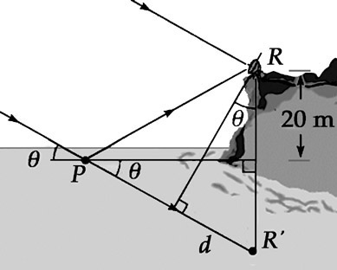

**ANS. FIG. P36.45**

Constructive interference first occurs for a path difference of

**[1]**



The angles *θ* in the figure are equal because they each form part of a right triangle with a shared angle at *R*′.

So the path difference is



The wavelength is



Substituting for *d* and *λ* in equation [1],



Solving for the angle *θ*,



**Challenge Problems**

**P36.46** For bright rings the gap *t* between surfaces is given by . The first bright ring has *m* = 0 and the hundredth has *m* = 99.



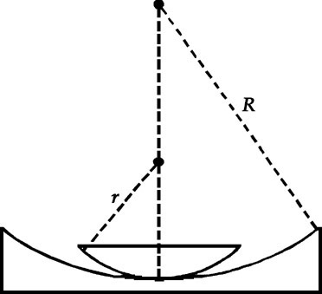

**ANS. FIG. P36.46**

So,



Call *rb* the ring radius. From the geometry shown in ANS. FIG. P36.46,



Since *rb* << *r*, we can expand in binomial series:



**P36.47** Refer to ANS. FIG. P36.47 for the geometry of the situation. At the air-film interface, Snell’s law gives



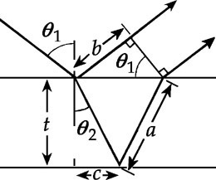

**ANS. FIG. P36.47**

Call *t* the unknown thickness of the film. Then,



The net shift for the second ray, including the phase reversal on reflection of the first, is



where the factor *n* accounts for the shorter wavelength in the film. For constructive interference, we require



The minimum thickness will occur when *m* = 0 and will be given by



Then,



and



which gives



**P36.48** The shift between the two reflected waves is where *a* and *b* are as shown in the ray diagram in ANS. FIG. P36.48, *n* is the index of refraction, and the term is due to phase reversal at the top surface. For constructive interference, where *m* has integer values. This condition becomes



**[1]**



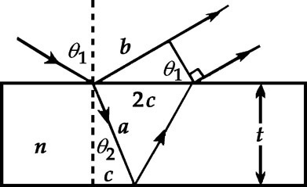

**ANS. FIG. P36.48**

From the figure’s geometry,



Also, from Snell’s law,



Thus,



With these results, the condition for constructive interference given in equation [1] becomes:



or



Using we have finally



**P36.49** (a) Minimum: for *m* = 0, 1, 2, …



Maximum: for *m*′ = 0, 1, 2, …



Note that *m* and *m*′ are distinct integer values, and must be consecutive because no intensity minima are observed between and



Also, so *m*′ = *m* – 1.



Thus, we have



so



(b) (wavelengths measured to )



Minimum:



2(1.40)*t* = 2(360 nm) *t* = 264 nm

Maximum:



2(1.40)*t* = 1.5(500 nm) *t* = 268 nm



Film thickness



**\*P36.50 Conceptualize** Study Figure 36.4 carefully, so that you understand the origin of the intensity difference on the screen.

**Categorize**The problem involves the *waves in interference* model in the special case of two-slit interference.

**Analyze** Although the light waves are in phase as they leave the slits, their phase difference ** at *P* dependson the path difference according to Equation 36.1: ** = *r*2 – *r*1 = *d*sin**. A *path* difference of ** (for constructiveinterference) corresponds to a *phase* difference of 2** rad. Therefore, a path difference of ** isthe same fraction of ** as the phase difference ** is of 2**:

(1)



Solve Equation (1) for ** and substitute from Equation 36.1:

(2)



Use the superposition principle to combine the electric field magnitudes given in the problem statement to find an expression for the magnitude of the resultant electric field at point *P*:



Expand the second sine function:



The intensity of the light is proportional to the time average of the square of the electric field magnitude, so square the above expression:



The intensity seen or measured on a screen will be the time-averaged intensity, so integrate the time-dependent intensity ratio in Equation (5) over one cycle:



The evaluation of the first and third integrals as uses the same argument as that associated with Figure 32.5. The second integral is of the sine function over an integral number of cycles, so its value is zero.



The intensity of the light is proportional to the time average of the square of the electric field magnitude, so, from Equation (6),

(7)



Substitute for ** from Equation (2):

(8)



Comparing Equation (8) to the requested equation, we see that they do not match. An obvious difference is the factor of 2 in the argument of the cosine function. From one of the trigonometric identities in the problem statement, we can write

(9)



Apply Equation (9) to rewrite the cosine function in Equation (8):



Finally, identify the constants in front of the bracket and any other constants as *I*max:

(10)



**Finalize** Equation (10) is identical to that requested in the problem.

|  |
| --- |
| **ANSWERS TO QUICK-QUIZZES** |

1. (c)
2. The graph is shown on the next page. The width of the primary maxima is slightly narrower than the *N* equals 5 primary width but wider than the *N* equals 10 primary width. Because *N* equals 6, the secondary maxima are 1 over 36 as intense as the primary maxima.

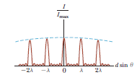

1. (a)

|  |
| --- |
| **ANSWERS TO EVEN-NUMBERED PROBLEMS** |

P36.2 The sine of the angle for *m* = 1 fringe is greater than 1, which is impossible.

P36.4 (a) 1.77 *µ*m; (b) 1.47 *µ*m

P36.6



P36.8



P36.10 (a) 13.2 rad; (b) 6.28 rad; (c) 1.27 × 10–2 deg; (d) 5.97 × 10–2 deg

P36.12



P36.14 (a) 22.6 cm; (b) 2.51 × 10–3; (c) 6.03 × 10–7 m; (d) 7.21°; (e) 2.28 cm; (f) The two answers are close but do not agree exactly. The fringes are not laid out linearly on the screen as assumed in part (a), and this nonlinearity is evident for relatively large angles such as 7.21°.

P36.16 11.3 m3

P36.18 (a) (b) See P36.18 (b) for full explanation; (c) 9:1



P36.20 (a) 638 nm; (b) A thicker film would require a higher order of reflection, so use a larger value of *m*; (c) 360 nm, 600 nm

P36.22 (a) green; (b) violet

P36.24



P36.26 (a) 97.8 nm; (b) Yes. Destructive interference occurs when (Eq. 36.17), where *m* is an integer. (There is a phase change at both faces of the film in Figure P36.26.) Hence, for *m* = 1, 2,… we obtain thicknesses of 293 nm, 489 nm, . . .



P36.28



P36.30 (a) See P36.30 (a) for full explanation; (b) 2.74 m

P36.32 (a) ~10–3 degree; (b) ~1011 Hz; (c) microwaves

P36.34



P36.36 (a) (b)



P36.38



P36.40 The number of fringes is *N* = *m* + 1 = 474 1. This number is less than   
5 000.

P36.42



P36.44 (a) *n*(*y*) = 1.90 – 0.0285 *y*/cm; (b) 32.3 cm; (c) The beam will continuously curve downward.

P36.46



P36.48 where *m* = 0, 1, 2, …



P36.50 See P36.50 for full explanation